7.13.3 Invoice Print
This function is used for invocing.
- When PDL/DL are confirmed by the warehouse, we need to issue an invoice.
- After the invoice is issued then we receive the invoice to our mailbox in pdf. (Your e-mail address has to be set in QAD CRM under each customer´s number).We still can do changes/corrections on the document at this moment.
- Then QAD is automatically posting the invoice. Usually in the evening and in the very morning (depends of setting in QAD). Then no changes/corrections are possible on the document anymore.

Sales Order: you can invoice a particular sales order number
Ship Date: date when DL was confirmed and the goods probably left the warehouse
Sold To + Bill To: number of customer / if you enter eg. GN Kantentechniek 62104920 (in CZ domain) you can invoice all at once only on one invoice (means consoladation of sales order is possible)
Ship To: number of delivery address of our customer´s client
Invoice Date: date of issue which will be visible on the invoice
Code Lang: 12+US works with Output: rolo (just displaying) / 53+US works with Output: pdf (real issuing)
Print Item Number: click the box when you want to see the whole article number on the invoice (not just a description, full name of it)
Updates: unclicked + Output: rolo = when we only want to see a draft of invoice in QAD as a report (it is always reccomended to check and see everything in advance, you can check the prices, comments, etc.)
Updates: clicked + Output: pdf: = when we really want to issue the invoice and received the invoice to mailbox (when you are absolutelty sure that everyhing on the invoice is correct)
+ Next (to get to the list/report of all sales order which are ready to be invoiced)
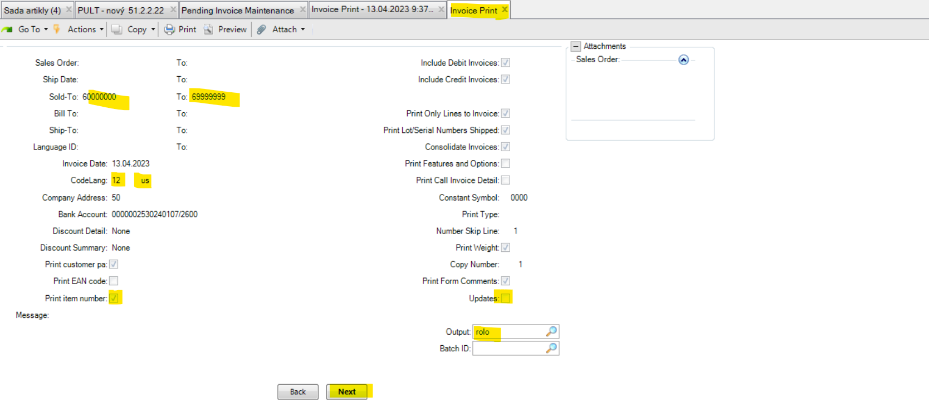
Here QAD shows us a list of all sales orders which are ready to be invoiced (based on Sold to party range 6000000-6999999)
Use arrow up+down to scroll and find the correct customer/Sold to party you need to invoice.
We can see below sales order for Witon, there is the carriage already entered, so we can invoice it.
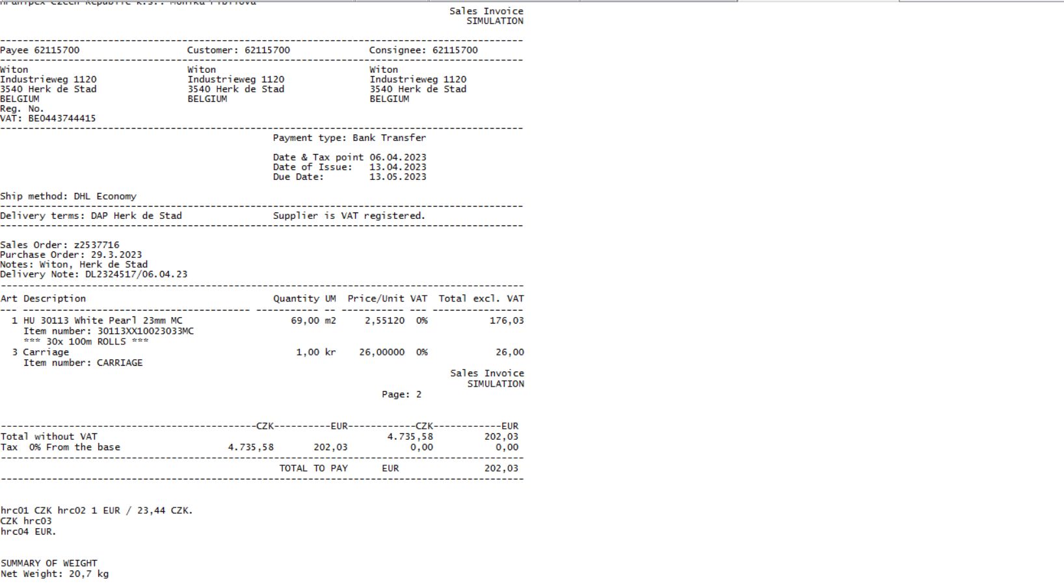
Lets invoice above z2537716 for Witon via 7.13.3.
Sales Order: enter sales order number
Code Lang: 12 + US (just to display the invoice in QAD)
Print Item Number: click on the box when you prefer to see the whole article number
Update: unclicked
Output: rolo
+ Next
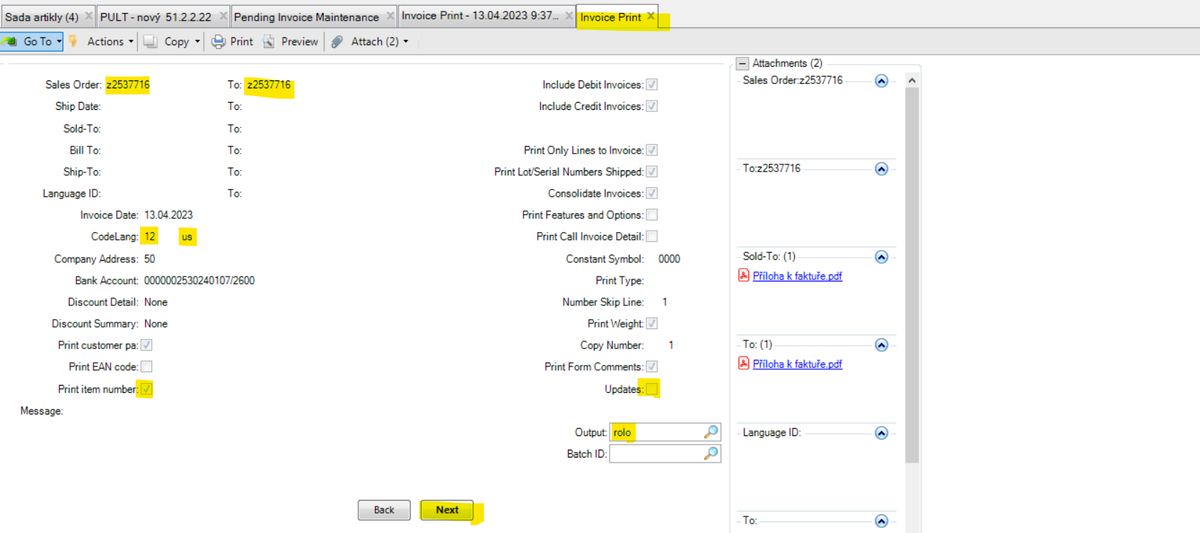
Now check all evenutall 0EUR prices on the document by using Ctrl+F = 0,0000.
Check Ship method, Delivery terms, Purchase Order number and the carriage.
Simply check all important fields for your particular customer.
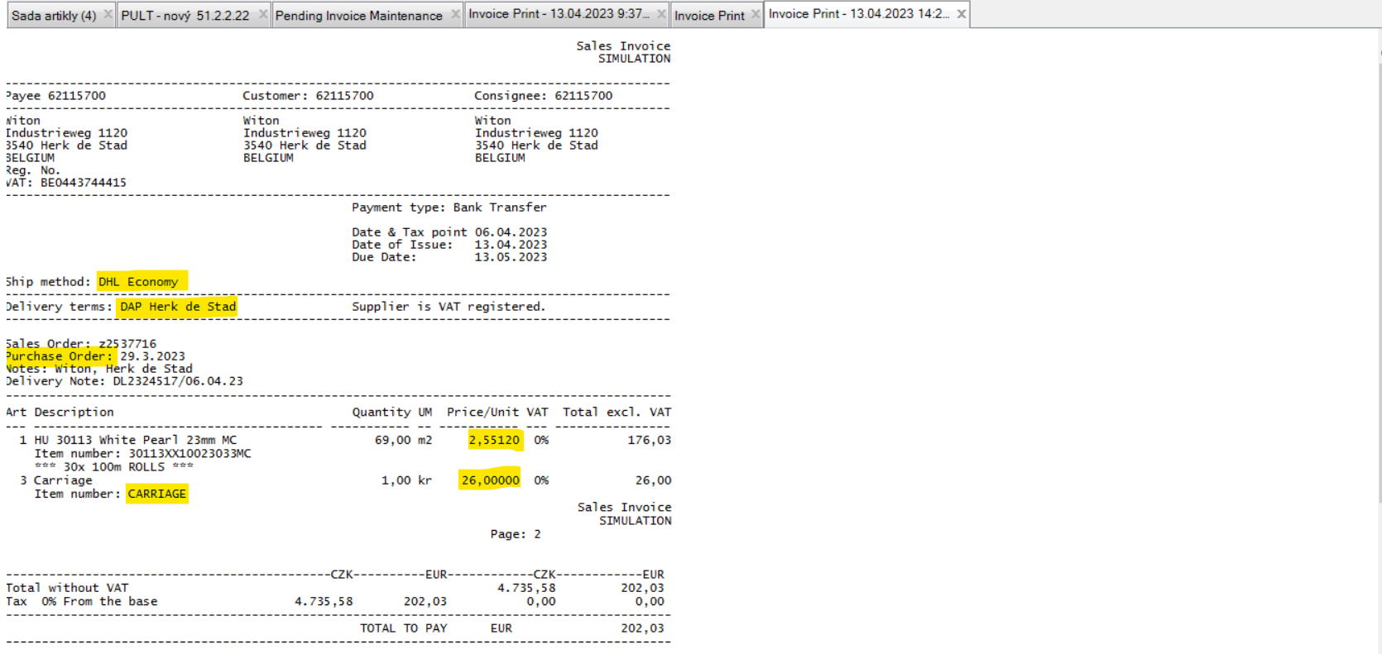
If everything is ok, just close this report.
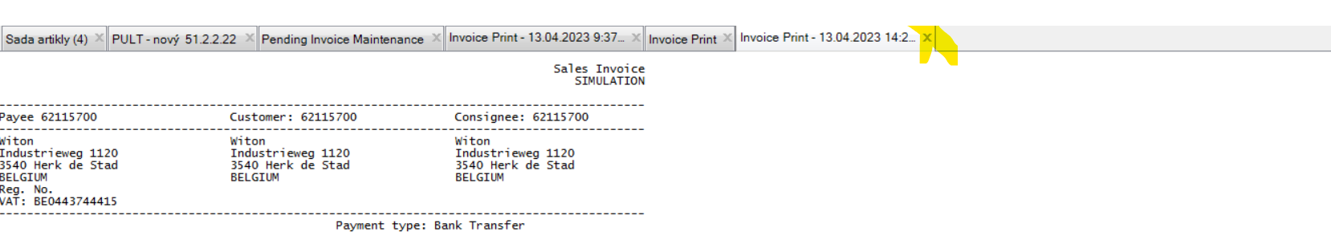
Go via 7.13.3 again.
Code Lang: 53+US
Output: pdf
+ Next (now the invoice has been issued and you will get it in pdf. to your mailbox)
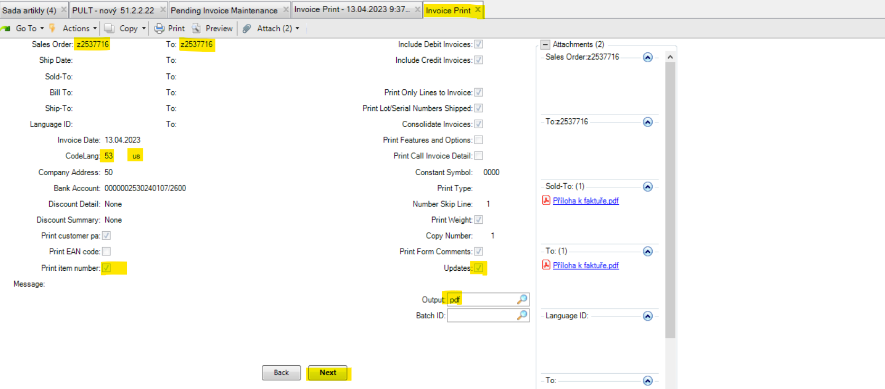
Lets invoice GN Kantentechniek (62104920 in CZ domain).
Enter all as below + Next.
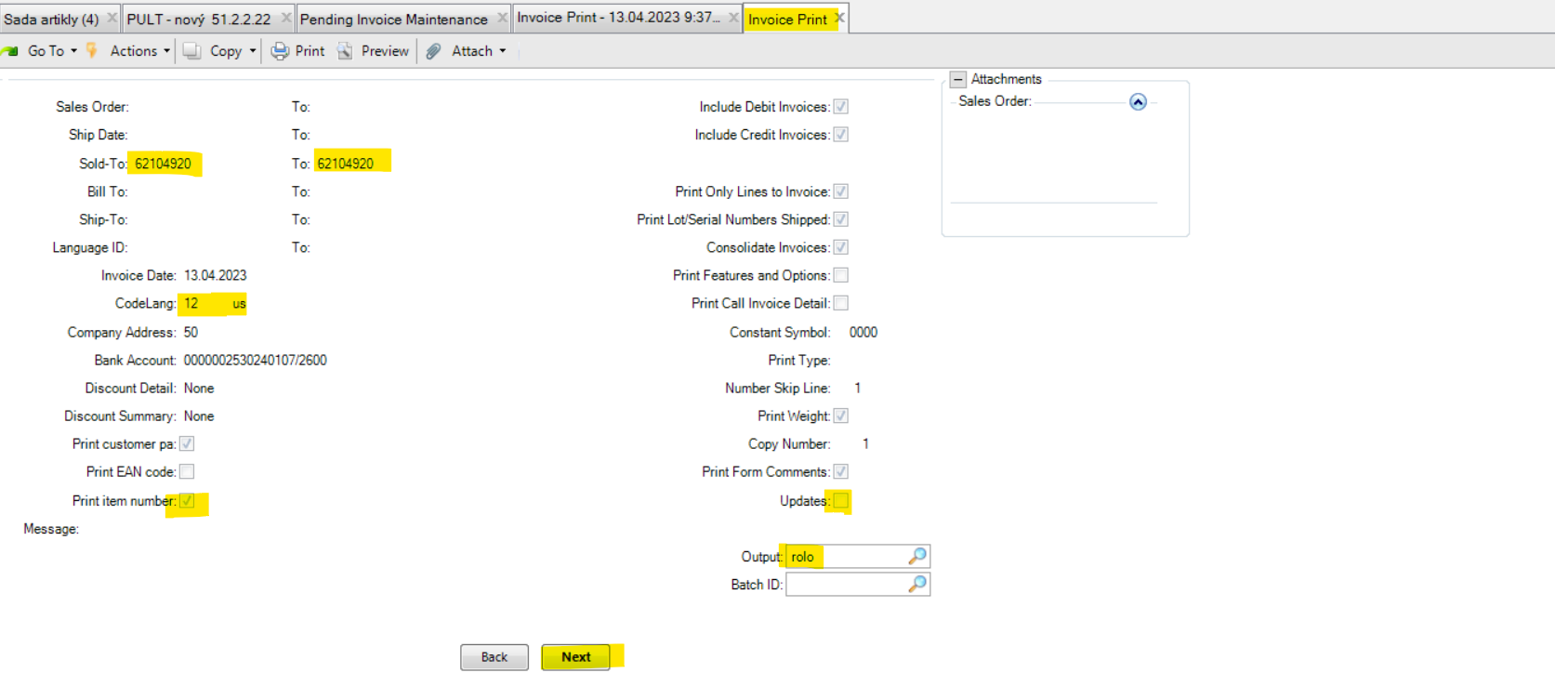

y this way you will get a list/report of sales orders which has been processed and confirmed by our warehouse.
QAD can recognize different Shipping methods (e.g. DHL Economy, Own Transport, Schenker Economy, DHL Express).
Means, if there are few sales orders with DHL Economy, it will be display in following list all together. Own transport will be consolidated. The same is valid for all other Shipping (delivery) method, e.g as for Schenker Economy, DHL Express, etc.
And this we need to check, sort correctly and invoice accordingly.
Own transport = sales orders are on the pallets / everything must be together on one invoice
DHL Economy = sales orders are in the boxes / everything must be invoiced by Ship to Parties / here can be also few sales orders to be sent directly to GN Kantentechnik to Horst = must be consolidated on one invoice.
Simply we usually sort or consolidate based on Shipping (delivery) methods and then according to Ship to parties (means delivery addresses).

The list contains a severeal different Ship to Parties.
The summary of the netto weight at the bottom of the invoice is counted for all sales orders from the list.
At the top of the header you see only the first Ship to party address and the rest of delivery addresses you can recognize only based on our Remarks. (This is also the reason why I always enter them to Remark when processing sales orders.)
All of them will be sent in the boxes via DHL ECOnomy.
We need to invoice them separately, order by order via 7.13.3 as above already discribed.

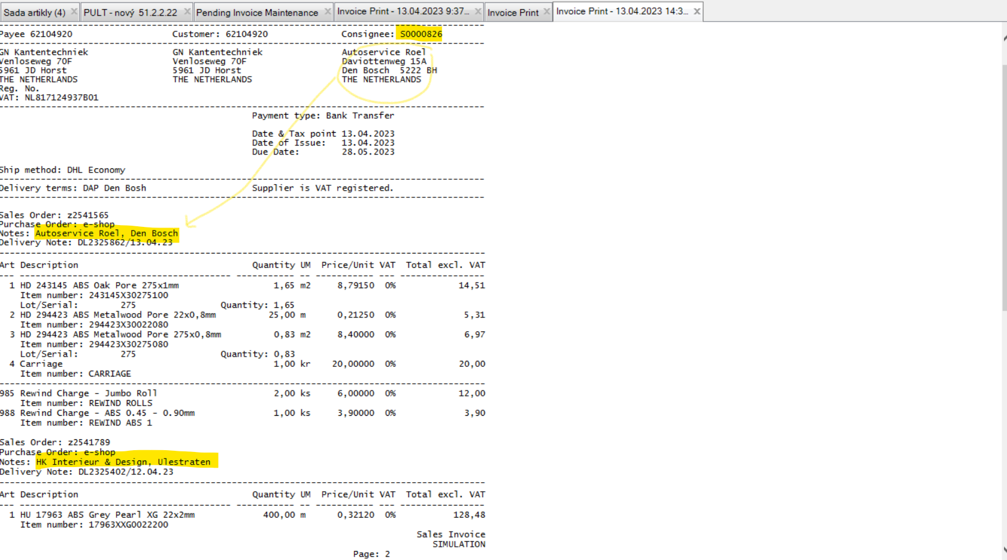
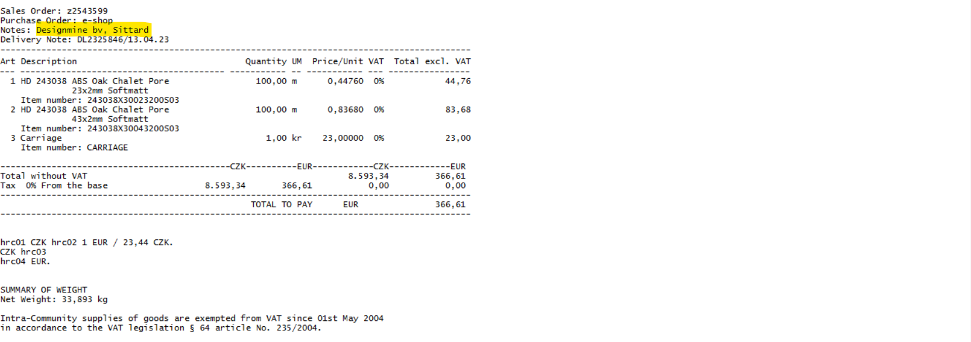

In case of need you can help yourself by using a fild Ship Date: in 7.13.3. By this you can easily sort sales orders by terms of sending. Just to get better kind of sorting. Mainly when there are mixed pallets and boxes shipments. I use it in case I forget or for some reason do not have time to invoice orders several days in a row.

